**Smart Travel Application**

**Functional Specification**

Final Product Description

The final product consists of a GUI application that will display a map of Ireland where users will be able to add destinations to finally be given a time-effective route. The routes will be generated by applying one of the following algorithms: brute force, nearest neighbor or a genetic algorithm. However, this will be completely hidden from users as the algorithm selection will be made internally based on the number of locations selected so that the response can also be provided in a timely manner. The functionalities users will be able to utilize are:

* Add a location to visit by selecting it on the map
* Select a location as the starting point for the tour
* Remove a selected location from the list
* Clear entire selection
* Submit selection to be processed

Interface and Interaction

In this section a tutorial with screenshots is included in order to describe how users will interact with the product and what it would look like.

Main Screen

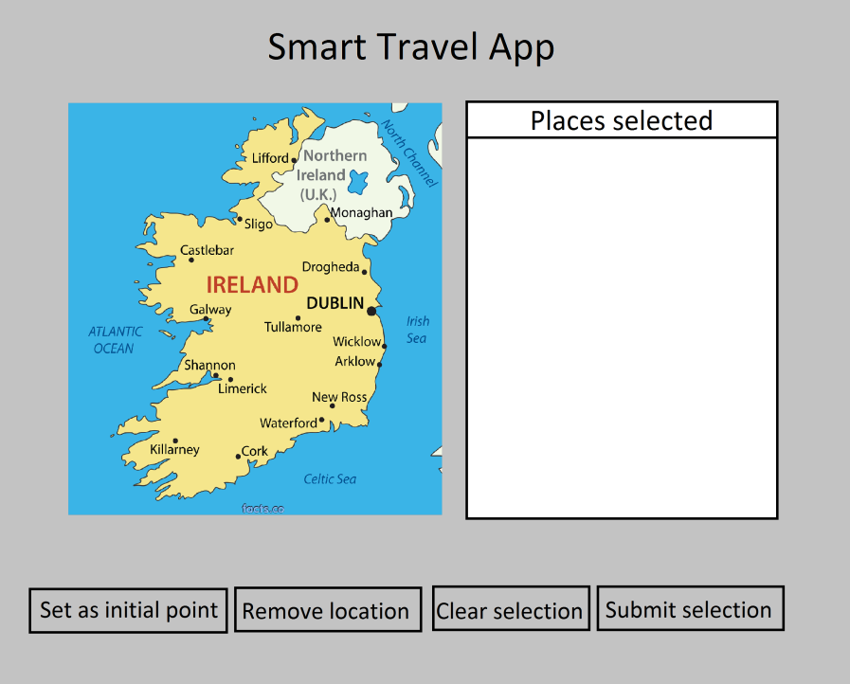

This is the screen displayed when the application is launched. It includes:

* Name of the app
* Map of Ireland
* List to hold selections
* Four buttons

Select a destination

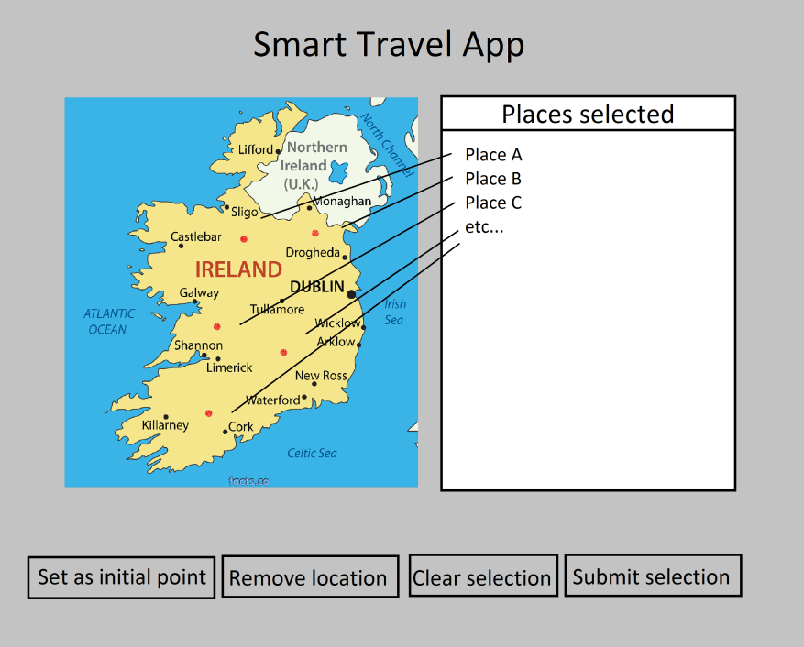

To add a destination to the list, users can simply click on the map and it will be added to the list on the right. This is how users will add all their destinations to the tour.

Select an initial point

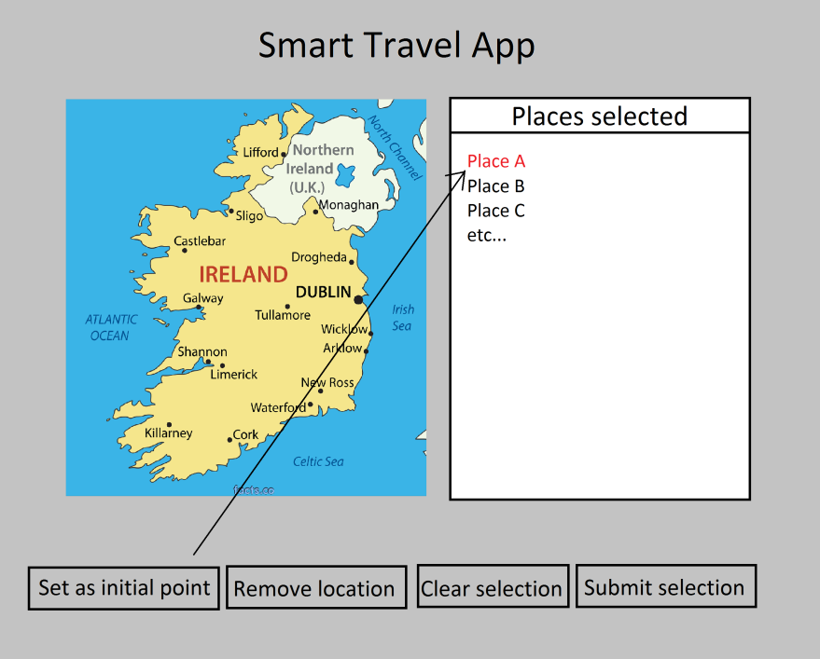

To set a destination as the starting point, users will need to select the location in the list, after users can click the Set as initial point button to make the selected location the starting point of the tour and the record will be displayed in red.

Remove one location from the list

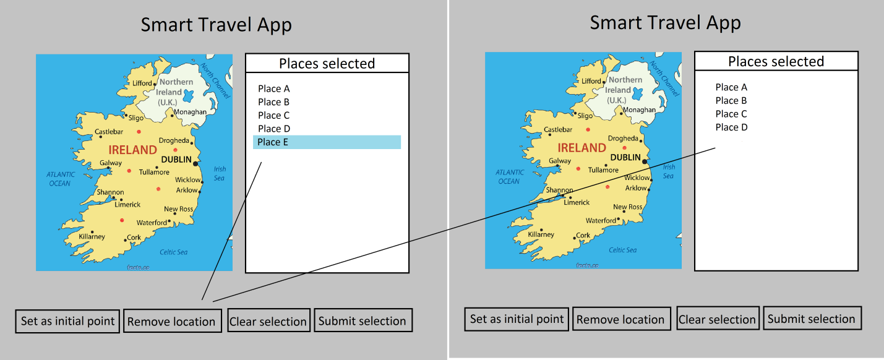

To remove a destination from the list, the user had to select it and then click the Remove location button. After this, the location will be removed from the list as shown in the screenshot.

Clear entire selection

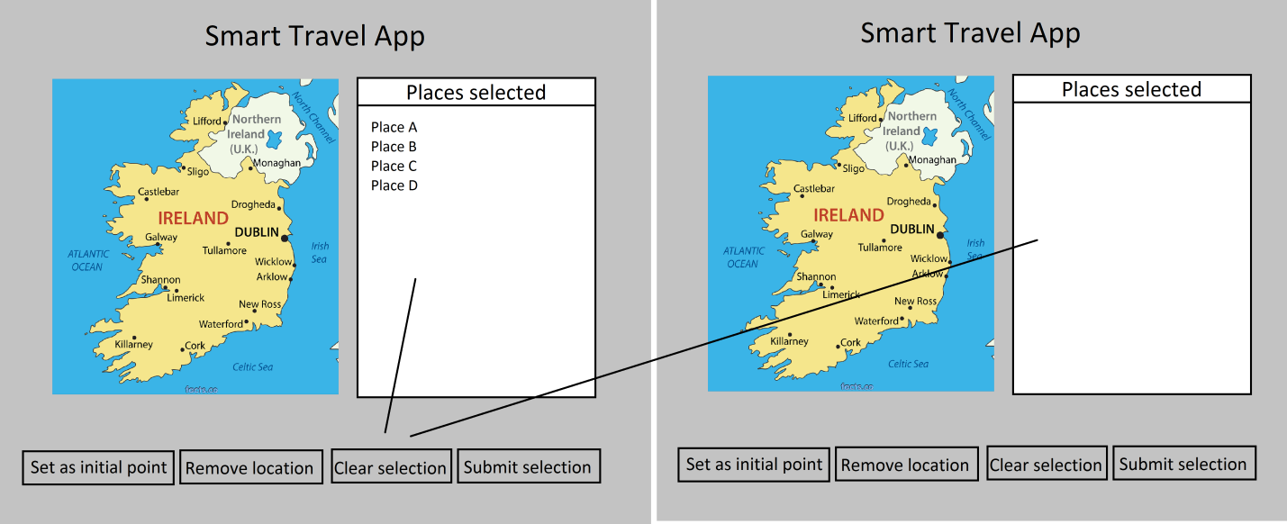

To clear the list of locations added to the tour, the user only needs to click the Clear selection button. All locations will be removed as shown in the screenshot.

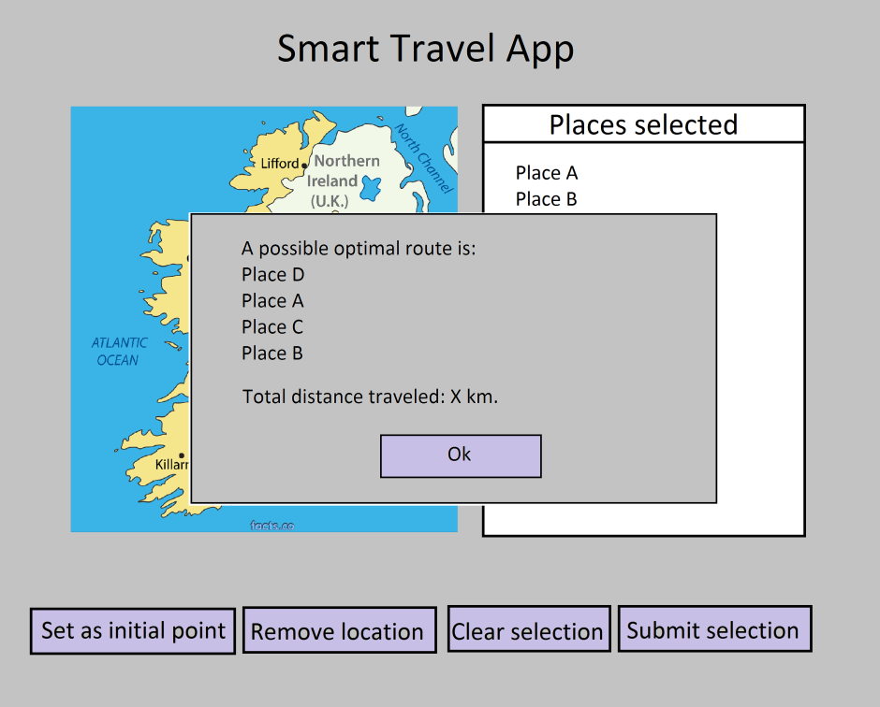

Finally, users will be able to submit their current selection to be processed. The result will be displayed in a pop up window and it will include all locations selected in the order provided after applying one of the algorithms, as well as the total distance of kilometers to travel.

An Ok button is added on the window so that the user can close it and proceed with a different selection.

Not enough destinations to process request

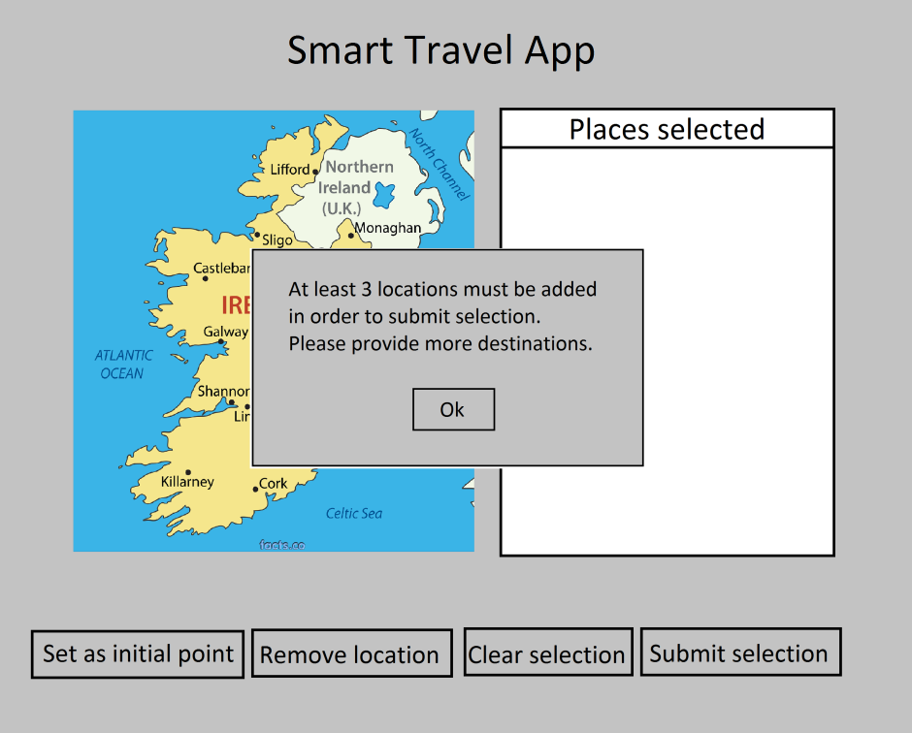

The minimum number of destinations required to process a request is 3. Otherwise an error message is displayed to let the user know more destinations are needed.